**School of Computer Science Engineering and Technology**

Course- BTech Type- Elective

Course Code- CSET335L Course Name-Deep Learning

Year- 2023 Semester- Even

**Lab Assignment 5 – Regularization**

We have gone through various ways to improve our deep learning model. Now it’s time to experiment and check the validity of regularization-based methods. For that let us do your experiment in the following manner and make a learning curve every time to see the impact.

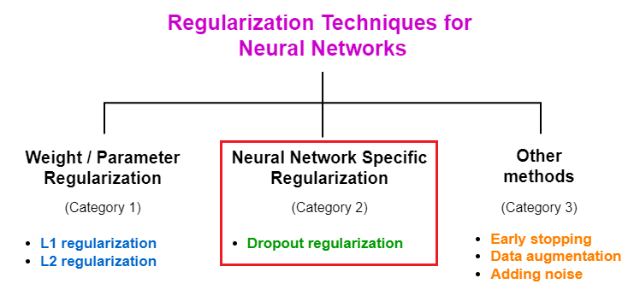

1. Impact of regularization
   1. No regularization
   2. L1 Norm
   3. L2 Norm
   4. Dropout
   5. Dropout plus L1 Norm
   6. Dropout plus L2 Norm

For every variation, you must check the testing/validation error for any 4 of the following datasets:

|  |  |
| --- | --- |
| **Dataset No** | **Dataset** |
| 1 | oxford_flowers102 |
| 2 | Fashion mnist |
| 3 | cars196 |
| 4 | Cifar100 |
| 5 | Yes_no (Any Dataset) |
| 6 | caltech_birds2011 |
| 7 | EMNIST |

NOTE: During the lab, you must show the results on 2 datasets.

Final submission to be done at LMS.